Assembly Guide

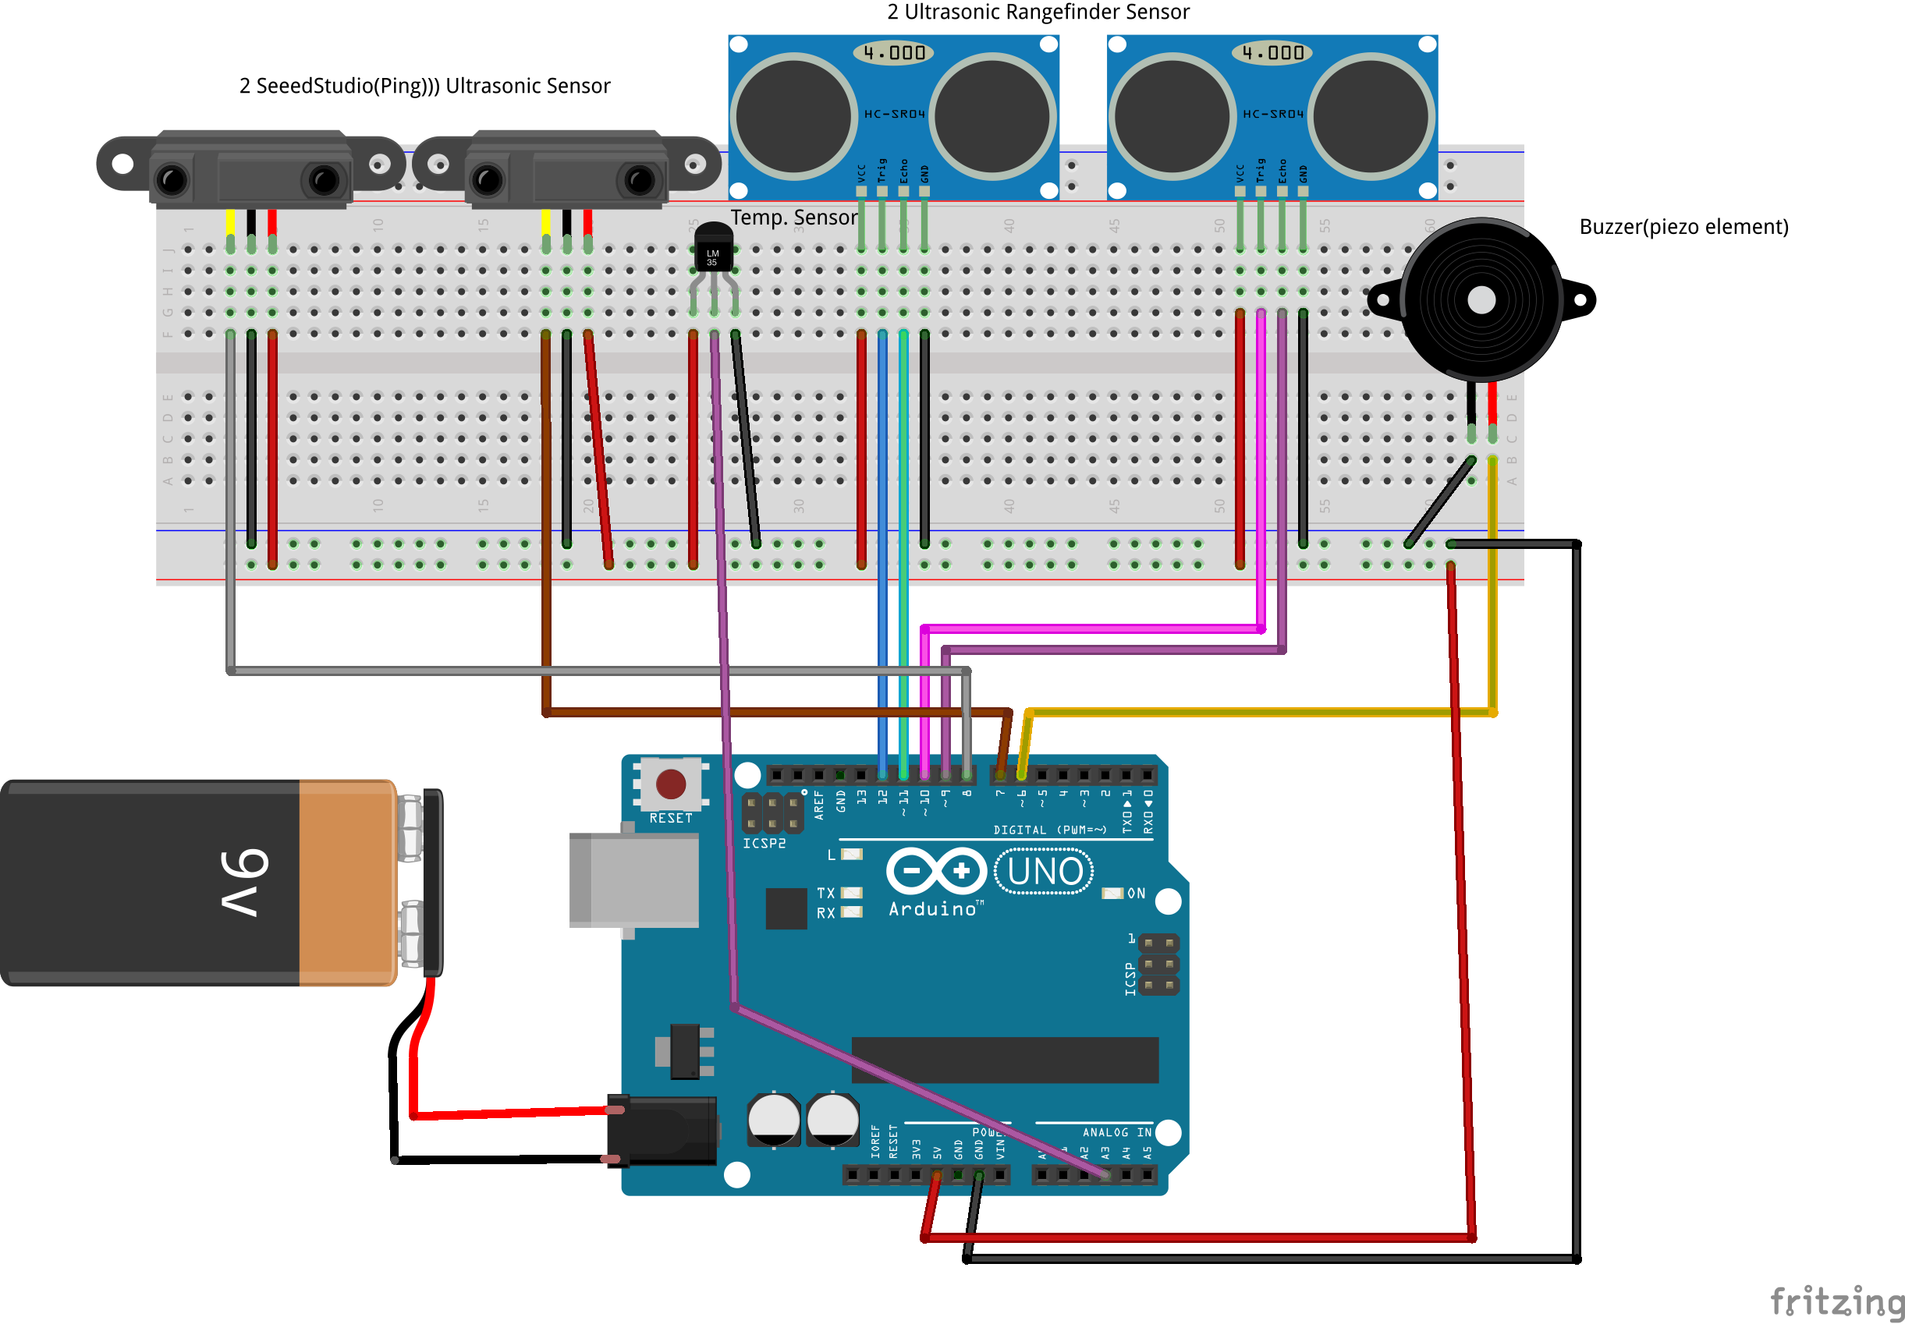

* Follow the above circuit diagram to connect the circuit
* Attach Thermal Imaging Sensor onto Baseball Cap
* Download the FIRSensor.apk and install it on your android phone
* Connect phone with Thermal Imaging Sensor using Bluetooth